TALK TODAY
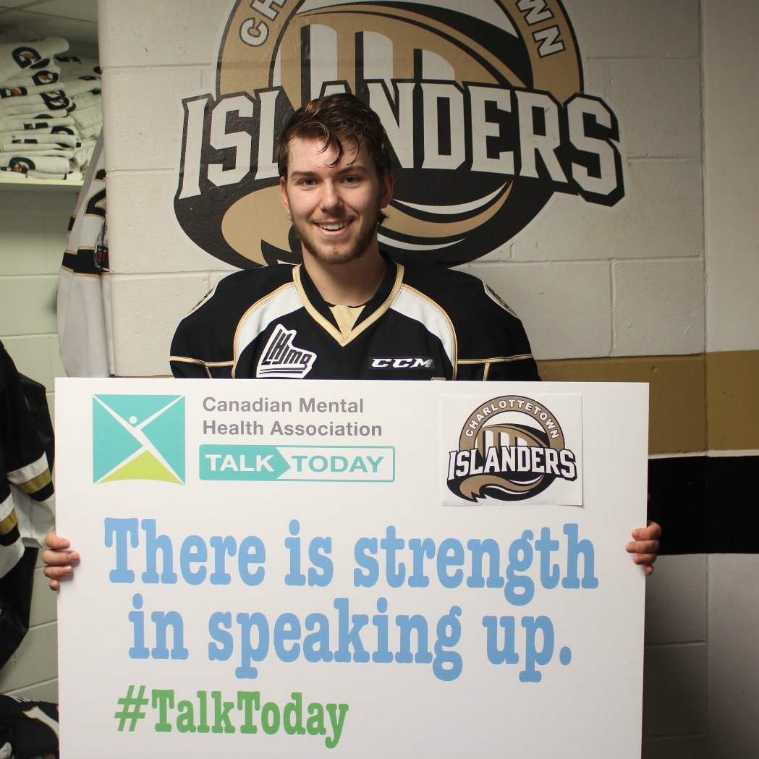

Talk Today is one of the most comprehensive mental health programs for amateur sports in Canada. Its aim is to promote the mental health of young athletes and to spread awareness about the benefits of positive mental health throughout communities across the country.

Originally launched by CMHA Ontario Division in partnership with the OHL in 2014, Talk Today provides an important opportunity to address the mental health needs of athletes across the province and across Canada. The program has become a valuable platform for CMHA branches, local sports teams and individual players to encourage open discussion about mental health within the community and the broader public.

How Talk Today helps

Mental Health Training for Players and Support Staff
All participants receive training in safeTALK, an accredited program that teaches individuals to recognize persons with thoughts of suicide and how to take action. Coaches, team staff and parents who provide support to the players can also receive safeTALK, as well as ASIST, a training which teaches people how to recognize individuals who are at risk and intervene to prevent suicidal thoughts and behaviours.

Mental Health Coach
Each team has a designated CMHA Mental Health Coach to provide resources and supports for the players as well as the people that surround them.

Mental Health Champion
Each team has a local Mental Health Champion, who acts as an advocate on mental health issues within the community and helps players connect with their local CMHA Mental Health Coach.

Talk Today Community Events
Each team hosts a Talk Today Community Event at one home game to show its support for mental health and raise awareness about CMHA mental health programs in the community.

How can I get involved with Talk Today?
Coaches, owners, parents or players interested in learning more can contact Amanda Brazil at (902) 628-3651 or via email at a.brazil@cmha.pe.ca.

Updated March 19, 2018
