CMHA’S MENTAL HEALTH WEEK PROCLAMATION

WHEREAS, May 2-8, 2022 is CMHA’s 71st Mental Health Week. The core objective of the week is mental health promotion.

WHEREAS, Mental Health Week’s 2022 theme will focus on Empathy – Be there, listen completely, and see the world through other people’s eyes. When times are tough we need to be there for each other. It’s how to really help.

WHEREAS, CMHA’s mission is to facilitate access to the resources people require to maintain and improve mental health and community integration, build resilience, and support recovery from mental illness.

NOW THEREFORE BE IT RESOLVED THAT (xxxx) hereby proclaims the week of May 2 to 8, 2022, as CMHA’S MENTAL HEALTH WEEK. We encourage everyone to #Get Real About How To Help.

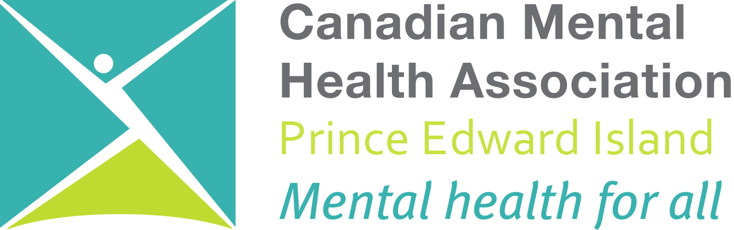
xxxx (insert name of group, business, town or city)

