CMHA’S MENTAL HEALTH WEEK PROCLAMATION

WHEREAS, CMHA’s Mental Health Week promotes mental health awareness through education campaigns offering practical ways to maintain and improve mental health and support recovery from mental illness.
WHEREAS, During Mental Health Week, CMHA is asking everyone to #Get Real About How You Feel. Recognizing, labeling and accepting our feelings are all part of protecting and promoting good mental health for everyone. One in five Canadians experiences mental health issues, a mental illness and/or addiction in any given year, but 5 in 5 of us - that’s all of us - has mental health.
WHEREAS, CMHA actively supports and encourages good mental health. We can all benefit from celebrating, promoting and acknowledging the role that good mental health plays in living a full and meaningful life. Everyone deserves to feel well, and understanding our emotions is a part of feeling well.

NOW THEREFORE BE IT RESOLVED THAT (xxxx) hereby proclaims the week of May 3 to 9, 2021, as CMHA’S MENTAL HEALTH WEEK. We encourage everyone to # Get Real About How You Feel.

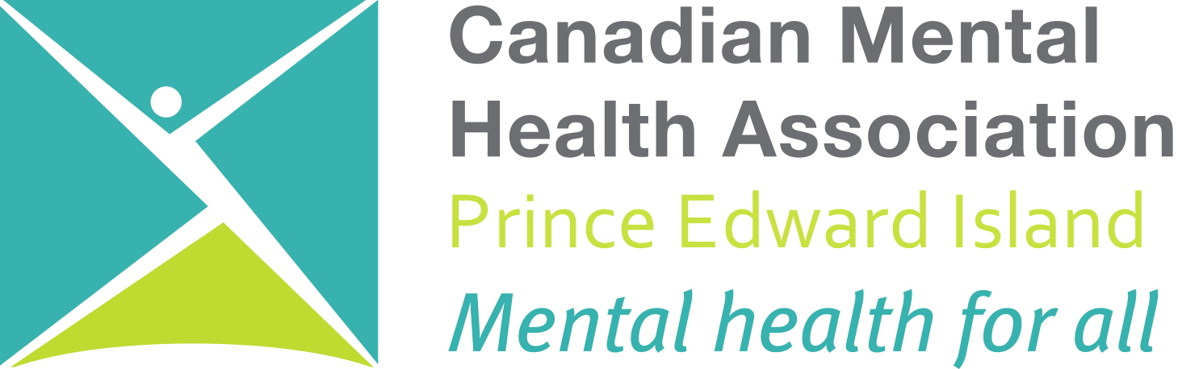
xxxx (insert name of group, business, town or city)

