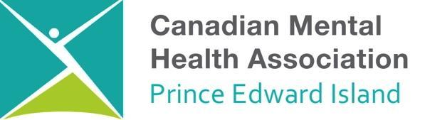
Employment Opportunity
Transitional Housing Program
Support Worker

The Transitional Housing Program of the PEI Division of the Canadian Mental Health Association requires the services of qualified individuals to work as Support Workers. The Transitional Housing Program is an intermediate step between emergency crisis shelter and permanent housing, and assists individuals with mental health and/or addictions needs to move towards greater autonomy and self-sufficiency, thereby increasing the likelihood of housing stability. The program aims to provide temporary intensive supportive housing, while improving overall wellbeing, personal growth and skill development. The program is staffed 24/7.

These positions are located in Charlottetown- 1 Full Time Positions Available
Hours of Work:
Rotating Shifts: 12-hour shifts - Days, nights, weekends.

Job Responsibilities:

- An understanding and ability to work within a recovery-oriented program delivery model
- Flexibility and a client-centered approach based on client needs
- Ability to provide client supervision and make decisions with minimal supervision
- Innovative with excellent problem solving, verbal and written communication skills
- Ability to work independently and within a team environment
- Ability to work collaboratively with community partners
- Highly motivated self-starter with the ability to multitask in a high pressure environment
- Ability to input data using documentation software, electronic client files and evaluation tools
- Knowledge of client support services and resources within the community
- Excellent assessment, crisis intervention, problem solving and organizational skills
- Support staff will be responsible for assisting participants with household duties including but not limited to cooking, cleaning, medication management, budgeting, etc. Duties can vary depending on the needs of the current participants within the program

Minimum Qualifications and Experience:

- Relevant university degree in Social Sciences (social work, psychology, etc.) or a community college diploma in a related subject area (Youth Worker, Human Services, RCW, Corrections, etc.).
- Demonstrated equivalencies and experience will be considered as alternative.
- Experience working with clients with complex mental health and addictions needs.
- Direct experience or in-depth knowledge of the social determinants of health and the population housing needs.
- Excellent communication skills, a team player, possess organizational skills, strong decision making and leadership skills.

Other Requirements:
- Valid driver’s license required
- Satisfactory criminal records check and vulnerable sector check
- CPR/First Aid
- Additional relevant education and experience will be considered an asset.

CMHA is an equal opportunity employer. We celebrate diversity and are committed to creating an inclusive environment for all employees.

Closing Date: 4pm, July 9th, 2021

Resume and cover letter should be forwarded to:
178 Fitzroy, P.O. Box 785
Charlottetown, Canada
k.cowie@cmha.pe.ca

Only those applicants receiving an interview will be contacted.

