Workshop Dates
May 26th and 27th, 2022
9:00 AM to 4 PM Daily

Location:
Murchison Centre, 17 St. Pius X Ave.
(behind the Irving on St. Peters Rd.)
Charlottetown, PEI
Cost:
$180.00 for the two-day workshop
- Includes materials & nutritional breaks
- Lunch is on your own
Registration:
Due to limited space, we cannot reserve seating. Seats will be confirmed on a first come, first served basis, upon registration with payment. To register, please complete the registration form below and send it with your check or money order to:
CMHA/PEI Division
178 Fitzroy Street, P.O. Box 785
Charlottetown, PEI
C1A 7L9
*Payment must accompany registration form. Please call to confirm availability.
*Debit card payments may be made in person at our Charlottetown office.
*Credit Card payments may be made over the phone at 566-3034
*Receipts will be available on the first day of training.
For more info call Les Wagner at 436-7399

Mental Health First Aid Basic – May 26th and 27th, 2022
Registration Form (Payment must accompany registration)
Name:________________________________________________________________________________________
Occupation:_________________________________Organization:_______________________________________
Address:______________________________________________________________________________________
Phone:________________________________________Fax:____________________________________________
Email:________________________________________________________________________________________

Mental Health First Aid – Basic Workshop
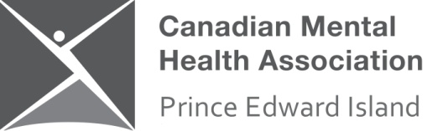
The Canadian Mental Health Association/PEI Division will be hosting a 2-day Mental Health First Aid - Basic workshop on May 26th and 27th, 2022
What is Mental Health First Aid?
Mental Health First Aid (MHFA) is the help provided to a person developing a mental health problem or experiencing a mental health crisis. Just as physical first aid is administered to an injured person before medical treatment can be obtained, MHFA is given until appropriate treatment is found or until the crisis is resolved.
The MHFA Canada program aims to improve mental health literacy and provide the skills and knowledge to help people better manage potential or developing mental health problems in themselves, a family member, a friend or a colleague.
Who should take an MHFA Canada course? Everyone!
Anyone can benefit from Mental Health First Aid (MHFA). It is open to members of the general public. Families affected by mental health problems, teachers, health service providers, emergency workers, frontline workers who deal with the public, volunteers, human resources professionals, employers and community groups are just a few of the groups who have benefited from MHFA.
Please note: Due to Covid-19 Guidelines, masks may be mandatory during some portions of this workshop.

