**Workshop Dates**

**January 18th and 19th, 2024**

**9:00 AM to 4 PM Daily**

Location:The Murchison Centre (17 St Pius X Ave, Ch’town)  
Cost:$250.00 for the two-day workshop  
• Includes materials & nutritional breaks  
• Lunch is on your own (12:00-1:00 PM)  
Registration:• To register, please complete the registration form below and email to division@cmha.pe.ca or fax to (902) 566-4643 or mail to:  
CMHA PEI Division  
P.O. Box 785  
Charlottetown, PE  
C1A 7L9  
• Payment must accompany the registration form to secure a seat and may be made by cheque,e-transfer ([payments@cmha.pe.ca](mailto:payments@cmha.pe.ca)), credit card by calling (902) 566-3034 or debit card, in person, at 178 Fitzroy Street, Charlottetown  
• Sorry, no refunds. If for some reason  
you are unable to attend, your registration fee can be transferred to a new date if notice is given 1 Weekprior. Failure to attend, without this notice, will result in forfeiture of registration fee, and no fee transfer to a future date will be permitted  
• Seats will be confirmed on a first come,  
first served basis

To inquire about space availability or  
other information email us at  
division@cmha.pe.ca or by phone (902)566-3034

**Mental Health First Aid Basic – January 18th and 19th, 2024**

**Registration Form (Payment must accompany registration)**

Name:________________________________________________________________________________________

Occupation:_________________________________Organization:_______________________________________

Address:______________________________________________________________________________________

Phone:________________________________________Fax:____________________________________________

Email:________________________________________________________________________________________

**Mental Health First Aid – Basic Workshop**

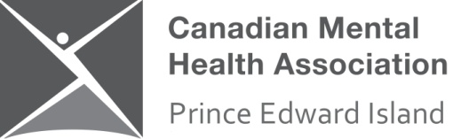

The Canadian Mental Health Association/PEI Division will be hosting a 2-day Mental Health First Aid - Basic workshop on January 18th and 19th, 2024

**What is Mental Health First Aid?**

Mental Health First Aid (MHFA) is the help provided to a person developing a mental health problem or experiencing a mental health crisis. Just as physical first aid is administered to an injured person before medical treatment can be obtained, MHFA is given until appropriate treatment is found or until the crisis is resolved.

The MHFA Canada program aims to improve mental health literacy and provide the skills and knowledge to help people better manage potential or developing mental health problems in themselves, a family member, a friend or a colleague.

**Who should take an MHFA Canada course**? Everyone!

Anyone can benefit from Mental Health First Aid (MHFA). It is open to members of the general public. Families affected by mental health problems, teachers, health service providers, emergency workers, frontline workers who deal with the public, volunteers, human resources professionals, employers and community groups are just a few of the groups who have benefited from MHFA.